Manage Azure Storage
- Task 1: Create and configure a storage account.
- Task 2: Create and configure secure blob storage.
- Task 3: Create and configure secure Azure file storage.

Go to Azure and type Storage Accounts
Select Create
Enter and select the following:
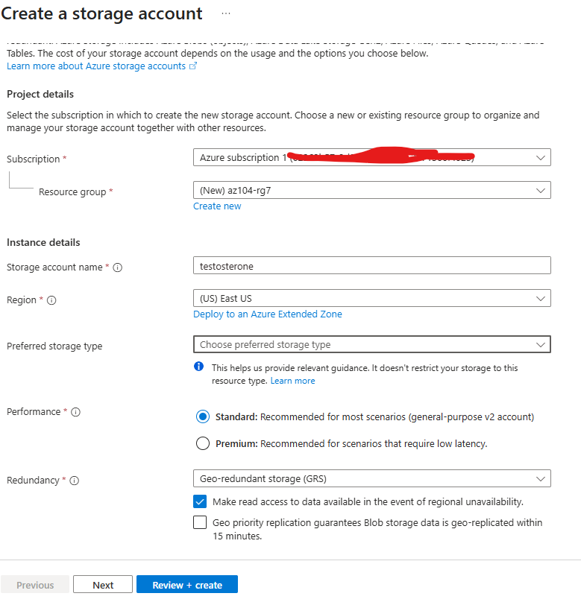

Disable Public network access
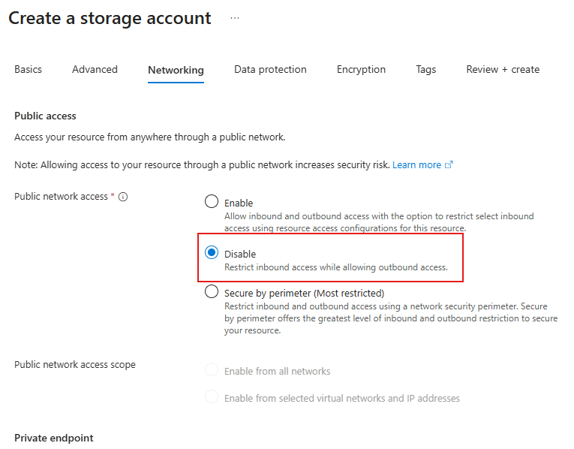

Review data protection and Encryption. Accept the defaults
Select Review + Create and click Create
Select Go to Resource

To enable Public Network Access select Disable and Select manage
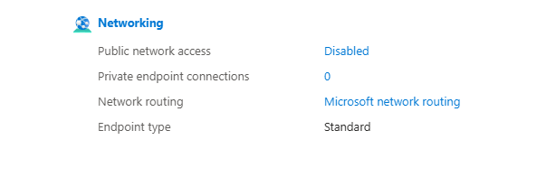
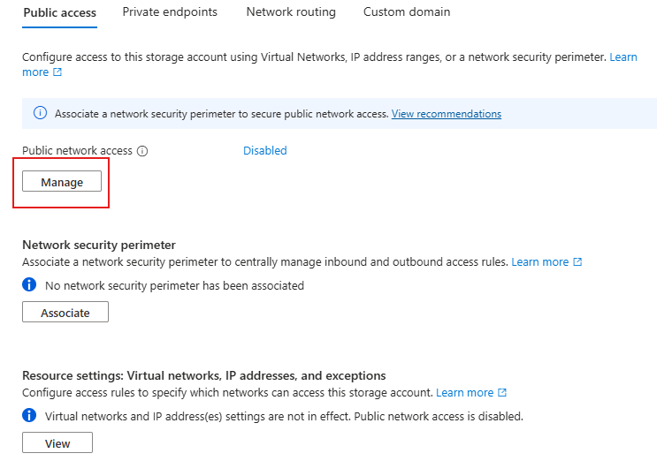

Change Public Network Access to Enabled
Change the Public network access scope to Enable from selected networks.
In the IPv4 Addresses section, select Add your client IPv4 address
Save your changes
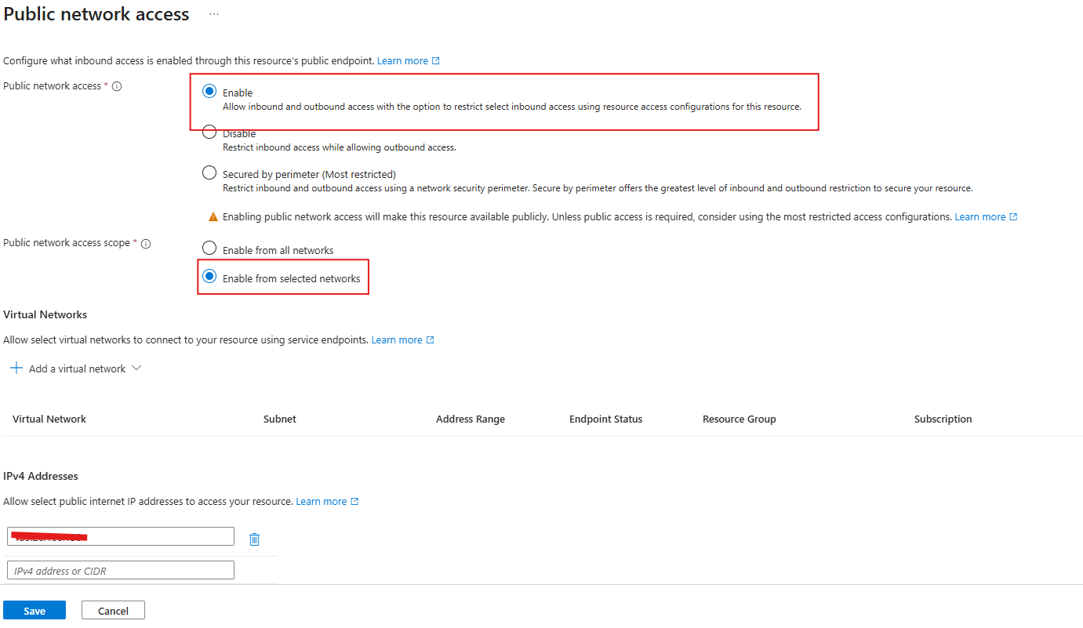

In the Data management blade (left corner), select Lifecycle management, and then select Add a rule.
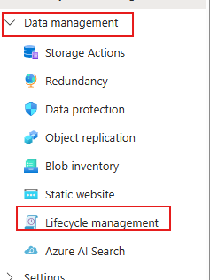

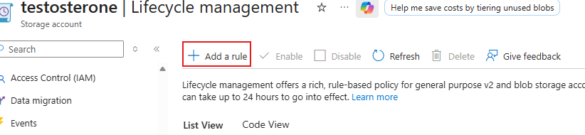

Make rule named Movetocool and hit next
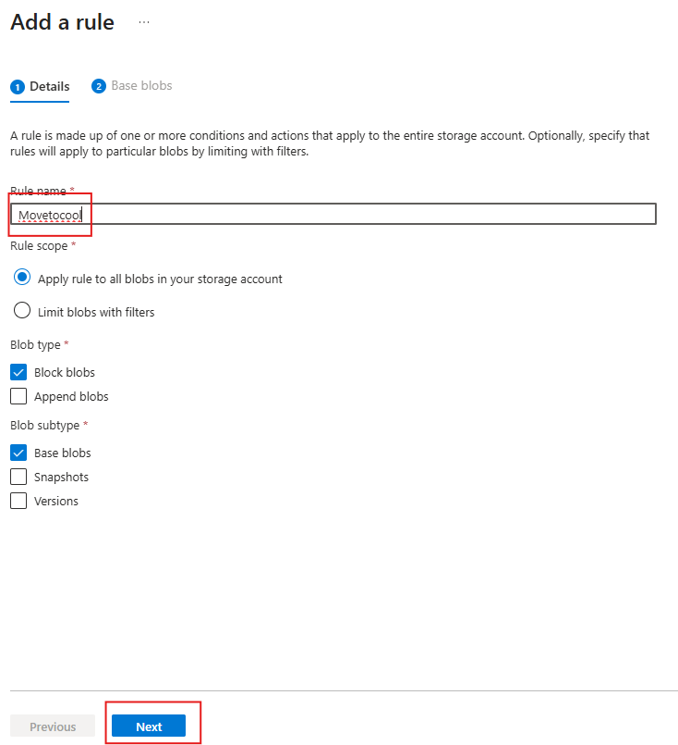

- On the Add rule page, if base blobs were last modified more than 30 days ago then Move to cool storage. Notice your other choices.
- Notice you can configure other conditions. Select Add when you are done exploring
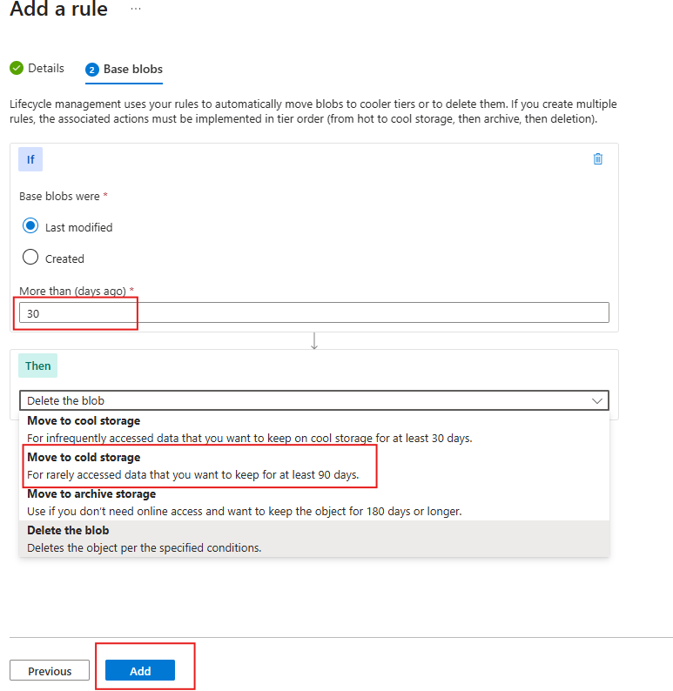

Task 2: Create and Configure secure Blob storage

Create a blob container and a time-based retention policy
- Continue in the Azure portal, working with your storage account.
- In the Data storage blade, select Containers.
- Click + Add container and Create a container with the following setting

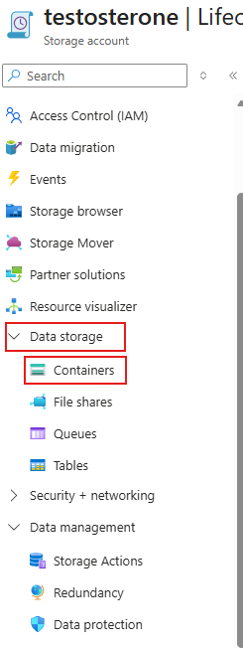

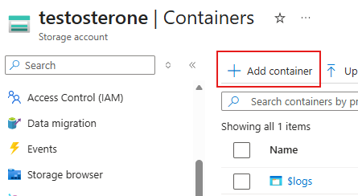

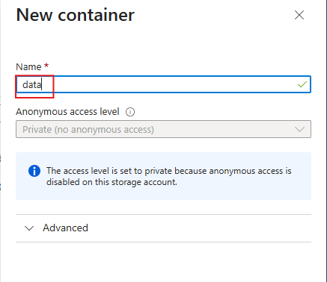

- On your container, scroll to the ellipsis (…) on the far right, select Access policy.
- In the Immutable blob storage area, select Add policy.
Setting

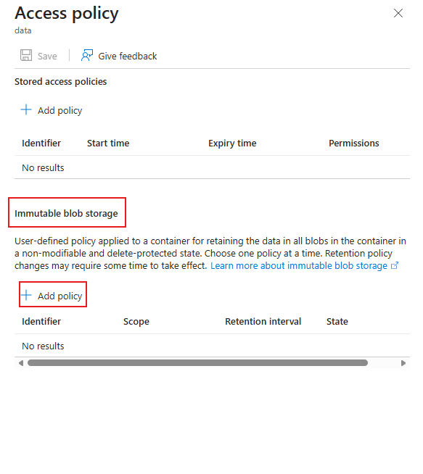

- In the Immutable blob storage area, select Add policy.
Setting | Value
Policy type | Time-based retention
Set retention period for | 180 days
- Select Save.
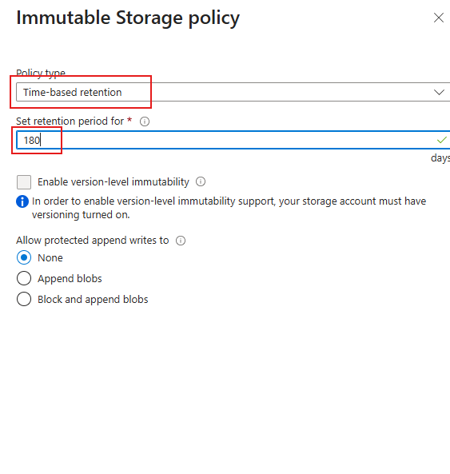

- Return to the containers page, select your data container and then click Upload.
- On the Upload blob blade, expand the Advanced section.
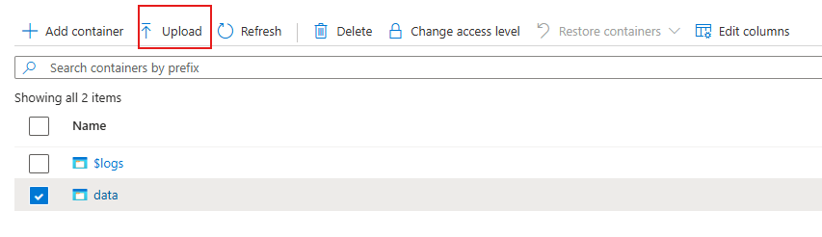
Setting | Value
Browse for files | add the file you have selected to upload
Select Advanced
Blob type | Block blob
Block size | 4 MiB
Access tier | Hot (notice the other options)
Upload to folder | securitytest
Encryption scope | Use existing default container scope

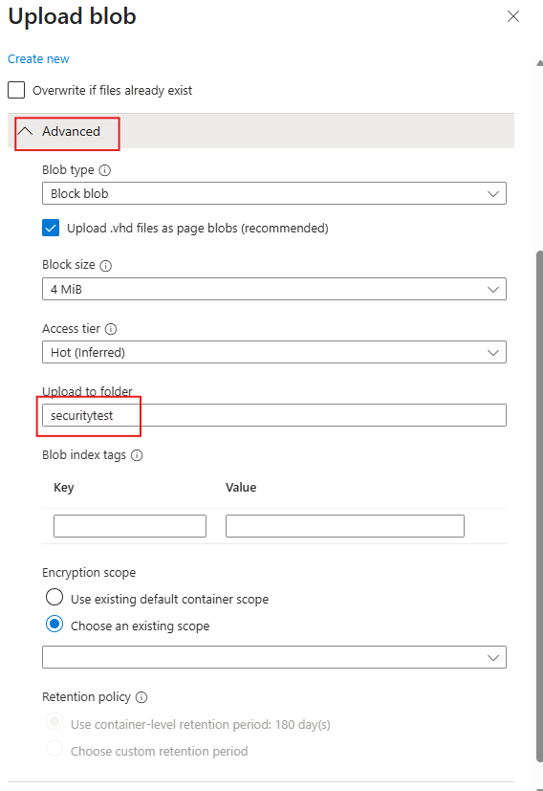

- Click Upload.
- Confirm you have a new folder, and your file was uploaded.
- Select your upload file and review the ellipsis (…) options including Download, Delete, Change tier, and Acquire lease.
- Copy the file URL (Settings –> Properties blade) and paste into a new InPrivate browsing window.
- You should be presented with an XML-formatted message stating ResourceNotFound or PublicAccessNotPermitted.

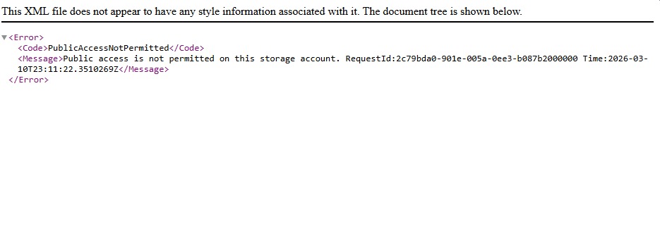

Configure limited access to the blob storage
- Browse back to the file that you uploaded and select the ellipsis (…) to the far right, then select Generate SAS and specify the following settings (leave others with their default values):
Setting | Value
Signing key | Key 1
Permissions | Read (notice your other choices)
Start date | yesterday’s date
Start time | current time
Expiry date | tomorrow’s date
Expiry time | current time
Allowed IP addresses | leave blank
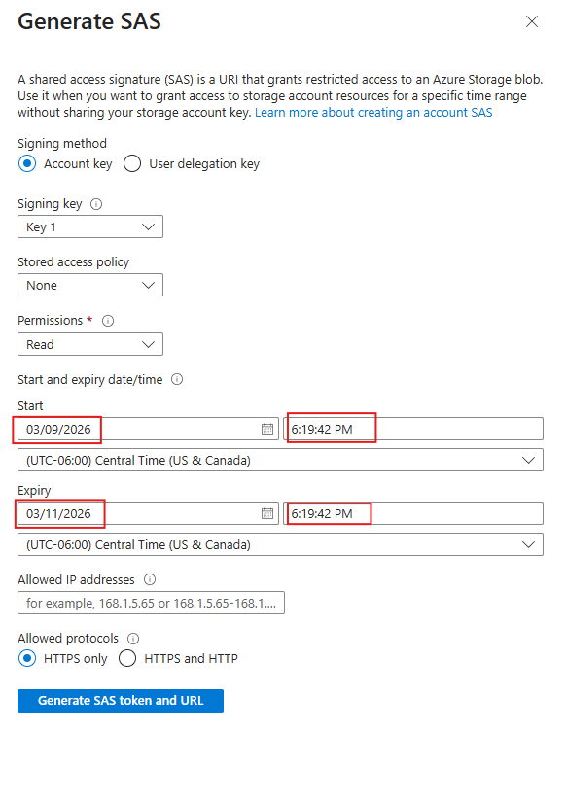

- Click Generate SAS token and URL.
- Copy the Blob SAS URL entry to the clipboard.
- Open another InPrivate browser window and navigate to the Blob SAS URL you copied in the previous step.
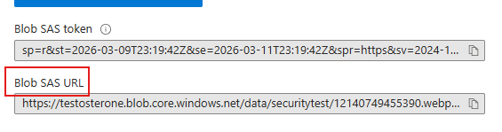

Note: You should be able to view the content of the file. (21 and up)


Task 3: Create and configure an Azure File storage
In this task, you will create and configure Azure File shares. You will use Storage Browser to manage the file share.
Create the file share and upload a file
- In the Azure portal, navigate back to your storage account, in the Data storage blade, click File shares.
- Click + File share and on the Basics tab give the file share a name, share1.
- Notice the Access tier options. Keep the default Transaction optimized.
- Move to the Backup tab and ensure Enable backup is not checked. We are disabling backup to simplify the lab configuration.
- Click Review + create, and then Create. Wait for the file share to deploy.
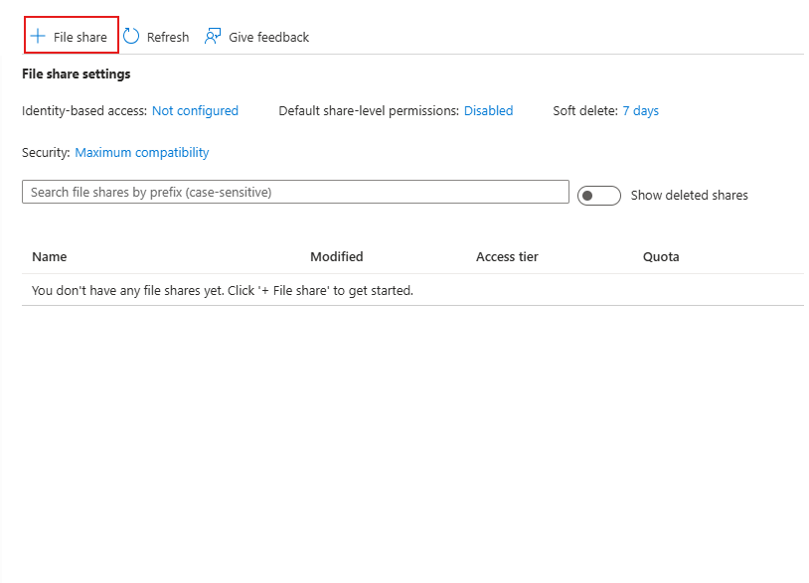
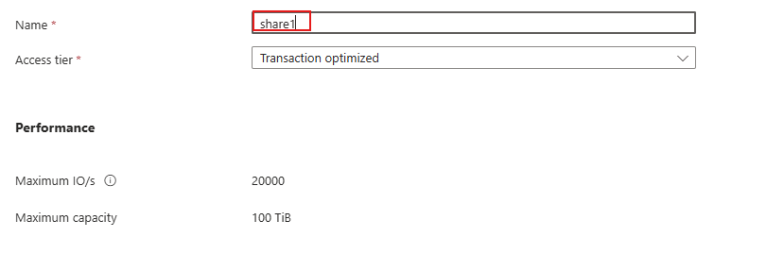

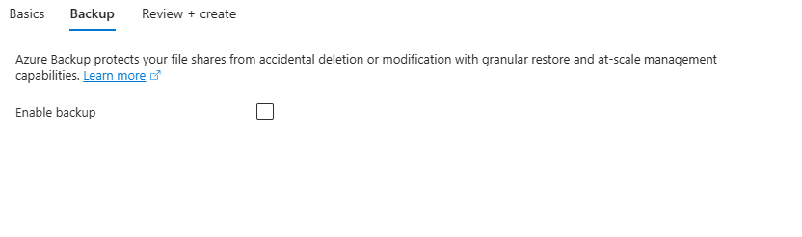

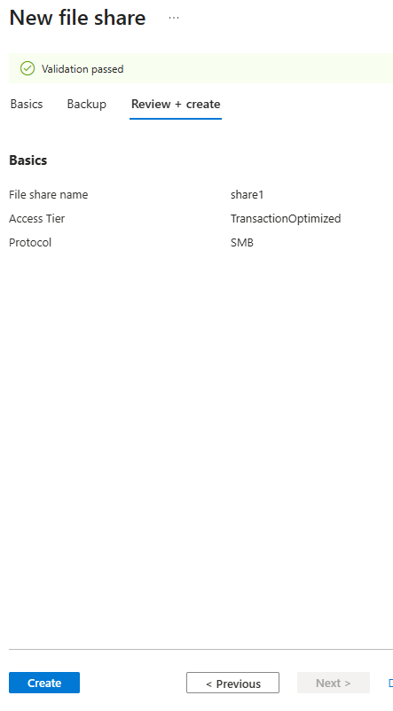

Explore Storage Browser and upload a file
- Return to your storage account and select Storage browser. The Azure Storage Browser is a portal tool that lets you quickly view all the storage services under your account.
- Select File shares and verify your share1 directory is present.
- Select your share1 directory and notice you can + Add directory. This lets you create a folder structure.
- Select Upload. Browse to a file of your choice, and then click Upload.
Note: You can view file shares and manage those shares in the Storage Browser. There are currently no restrictions.

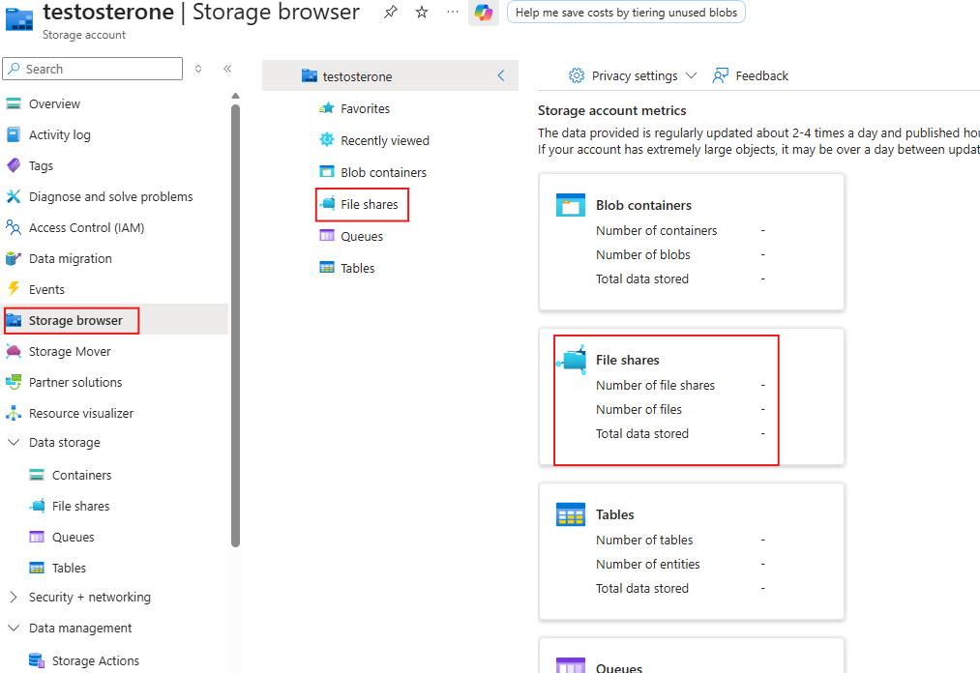

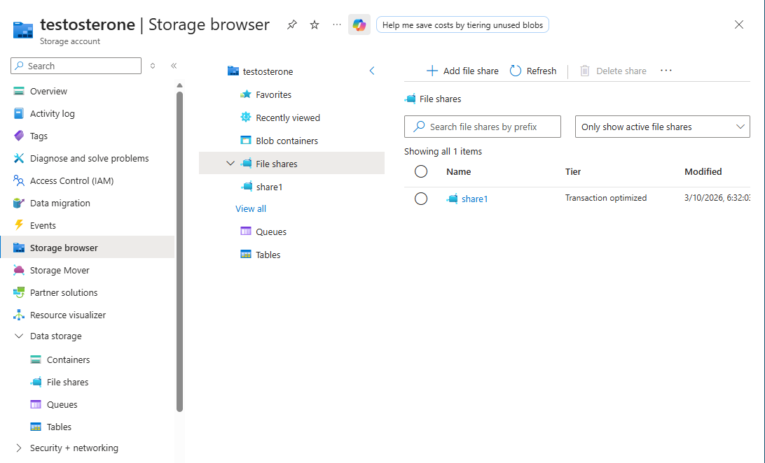

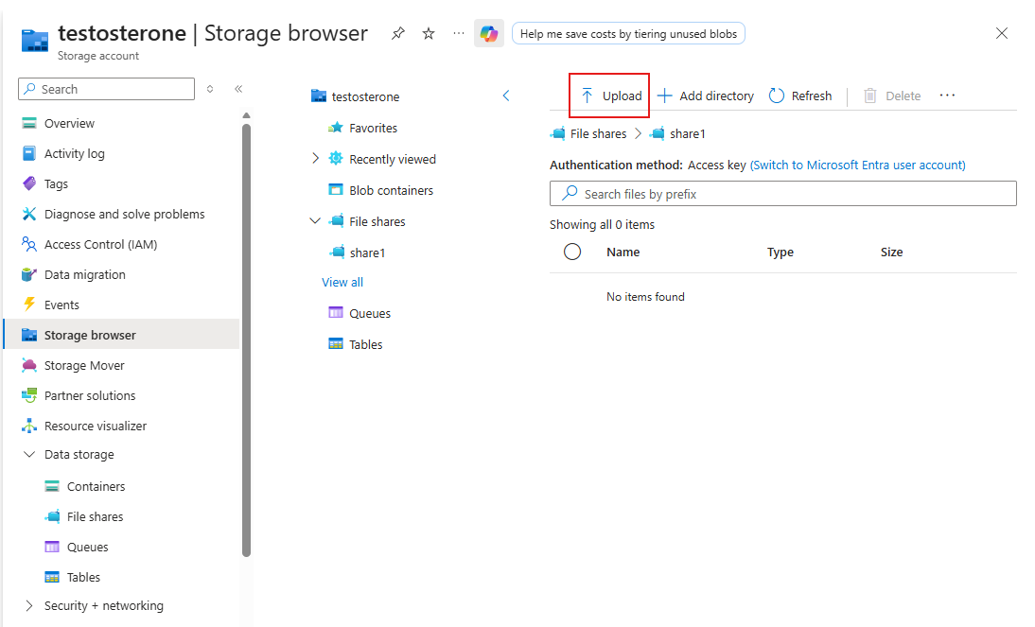

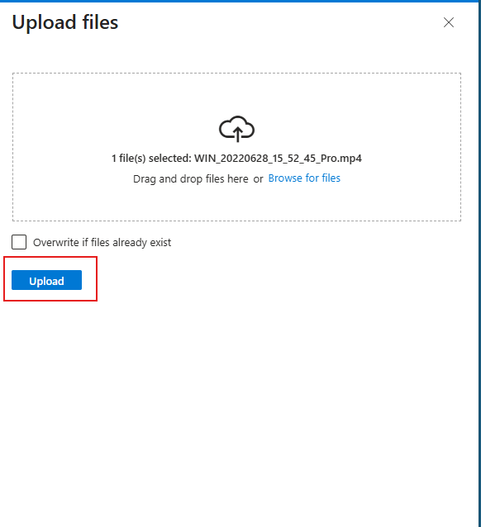
Restrict network access to the storage account
- In the portal, search for and select Virtual networks.
- Select + Create. Select your resource group. and give the virtual network a name, vnet1.
- Take the defaults for other parameters, select Review + create, and then Create.
- Wait for the virtual network to deploy, and then select Go to resource.
- In the Settings section, select the Service endpoints blade.
  - Select Add.
  - In the Service drop-down select Microsoft.Storage.
  - In the Subnets drop-down check the Default subnet.
  - Click Add to save your changes.
- Return to your storage account.
- In the Security + networking blade, select Networking.
- Under Public network access select Manage.
- Select Add a virtual network and then Add existing network.
- Select vnet1 and default subnet, select Add.
- In the IPv4 Addresses section, Delete your machine IP address. Allowed traffic should only come from the virtual network.
- Be sure to Save your changes.
Note: The storage account should now only be accessed from the virtual network you just created.
- Select the Storage browser and Refresh the page. Navigate to your file share or blob content.
